**Popular Methods of Analysis and Superposition**

**Lab #4**

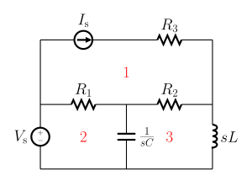

ECE 1101 Lab, Section 6

Date: Thursday, September 19th, 2019

Kyler Martinez, Daniel Tan

Equipment Used In The Experiment:

* Lab-Volt Power Supply
  + Make/Model: 1224 AC/Dual DC Power Supply
  + Serial Number: N/A
* Keysight 4 ½ Digital Display Multimeter
  + Make/Model: U3401A
  + Serial Number: MY56150032
* Keysight Triple Output DC Power Supply
  + Make/Model: E3630A
  + Serial Number: MY56186189

Materials Used In The Experiment:

* Breadboard
* 1kΩ Resistor
* 3.3kΩ Resistor
* 6.8kΩ Resistor

Objective:

The objectives of the lab were to validate mesh analysis, nodal analysis, and the principle of superposition with experimental data and compare it to theoretical data.

Background Theory:

The background theories used in this lab are mesh analysis which uses applies KVL and Ohm’s law to solve planar circuits for the currents and node analysis which applies KCL and Ohm’s law to find the voltage between nodes.

Procedure: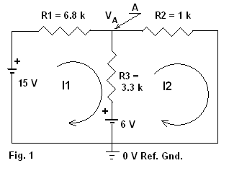

To validate mesh analysis we had to set up our breadboard to look like the circuit in Figure 1, we then measured the current through R1 and used that as our mesh 1 current, we then measured the current through R2 as our mesh 2 current. We then used the mesh current equations to validate mesh analysis and compare our measured values.

To validate the nodal analysis, we measured the voltage drop between node VA and right before R3, when using the nodal equations to solve for the theoretical nodal voltage and we then compared our experimental and theoretical values to validate the nodal analysis.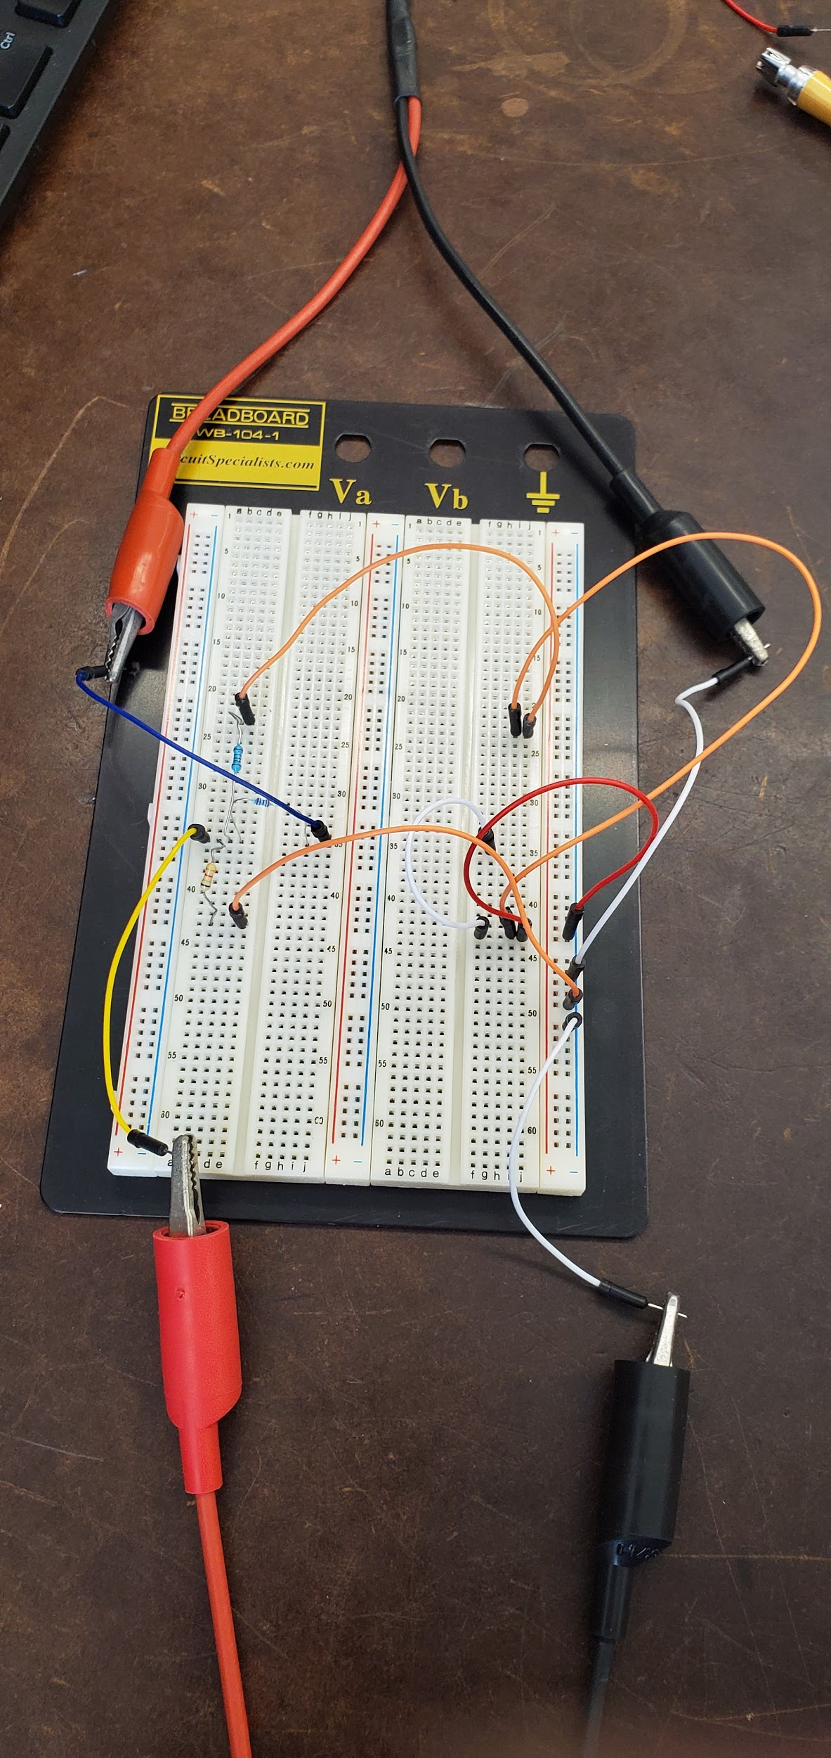

To validate the principle of superposition we took the current I2 after shoring, removing, each power supply and leaving only in. We then repeated this process and recorded the VA. To validate the principle of superposition we added both of the voltage and current values and compared the sum to the original measured value.

Data:

Resistor Values

|  |  |  |  |
| --- | --- | --- | --- |
| Resistor | R1 = 6.8 kΩ | R2 = 1 kΩ | R3 = 3.3 kΩ |
| Measured Resistance | R1 = 6.720 kΩ | R2 = 0.9965 kΩ | R3 =3.2975 kΩ |

Mesh Currents

|  |  |  |
| --- | --- | --- |
| Measured Current | I1= 1.7953 mA | I2=2.7090 mA |
| Calculated Current | I1=1.8179 mA | I2=2.7933 mA |
| % Discrepancy | 1.2432 % | 3.0179 % |

Calculations for Mesh Currents:

I1(R1 +R3)-R3I2=9

I2(R2 +R3)-R3I1=6

Voltage Node Analysis

|  |  |
| --- | --- |
| Measured Voltage VA | 2.7879 V |
| Calculated Voltage VA | 2.7836 V |
| % of Discrepancy | .1545 % |

Calculations for Node Voltage:

VA/R2 + (VA-15)/R1 + (VA-6)/R3 =0

Principle of Superposition

|  |  |  |  |
| --- | --- | --- | --- |
| Measured Current | I2= 2.709 mA | I2’= 1.4867 mA | I2’’= 1.2157 mA |
| Measured Voltage | VA= 2.7879 V | VA’= 1.5369 V | VA’’= 1.2515 V |

|  |  |
| --- | --- |
| I2 by Superposition & % Discrepancy | I2= I2’+I2’’= 2.7024 mA & .2436 % |
| V2 by Superposition & % Discrepancy | VA= VA’+VA’’= 2.7884 V & .0179 % |

Conclusion:

In the end, our experiment ended with results that did validate the calculations from nodal and mesh analysis as well as the principle of superposition. The discrepancies for the measured current and the theoretically calculated currents are 1.24% and 3.02%. The values we got were very close to the calculated values which confirms the method of mesh analysis. The difference may have been caused due to slight fluctuations in our power supply causing the voltage to drift. We then also measured the voltage through two nodes which yielded a discrepancy of 0.15% compared to the theoretical calculations. This percentage is quite low, so with almost identical results, we have verified that the calculations of node analysis are accurate.

The final step of our lab was using the principle of superposition where we compared the overall current and voltage to find the discrepancies between the two voltage sources. In the end, the discrepancy for the current was 0.24% and the voltage was 0.01%. The discrepancy is most likely due to the wear and tear of our resistors or the drifting of our voltage source, as the differences were very small and does not validate super positioning.

**PSpice Simulation**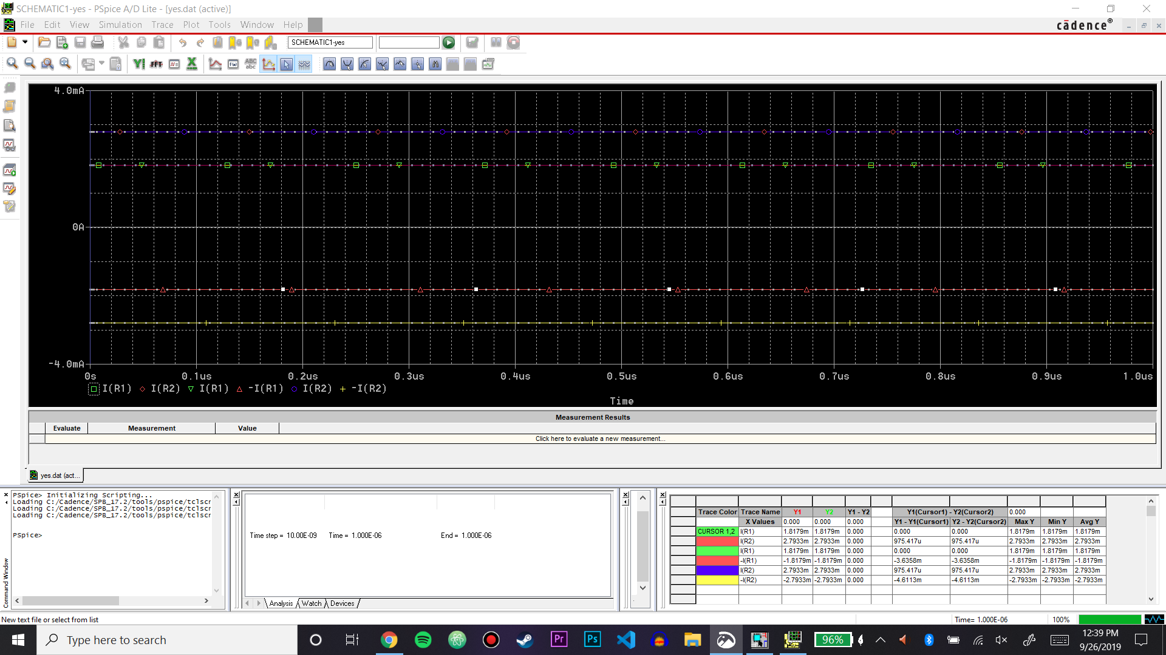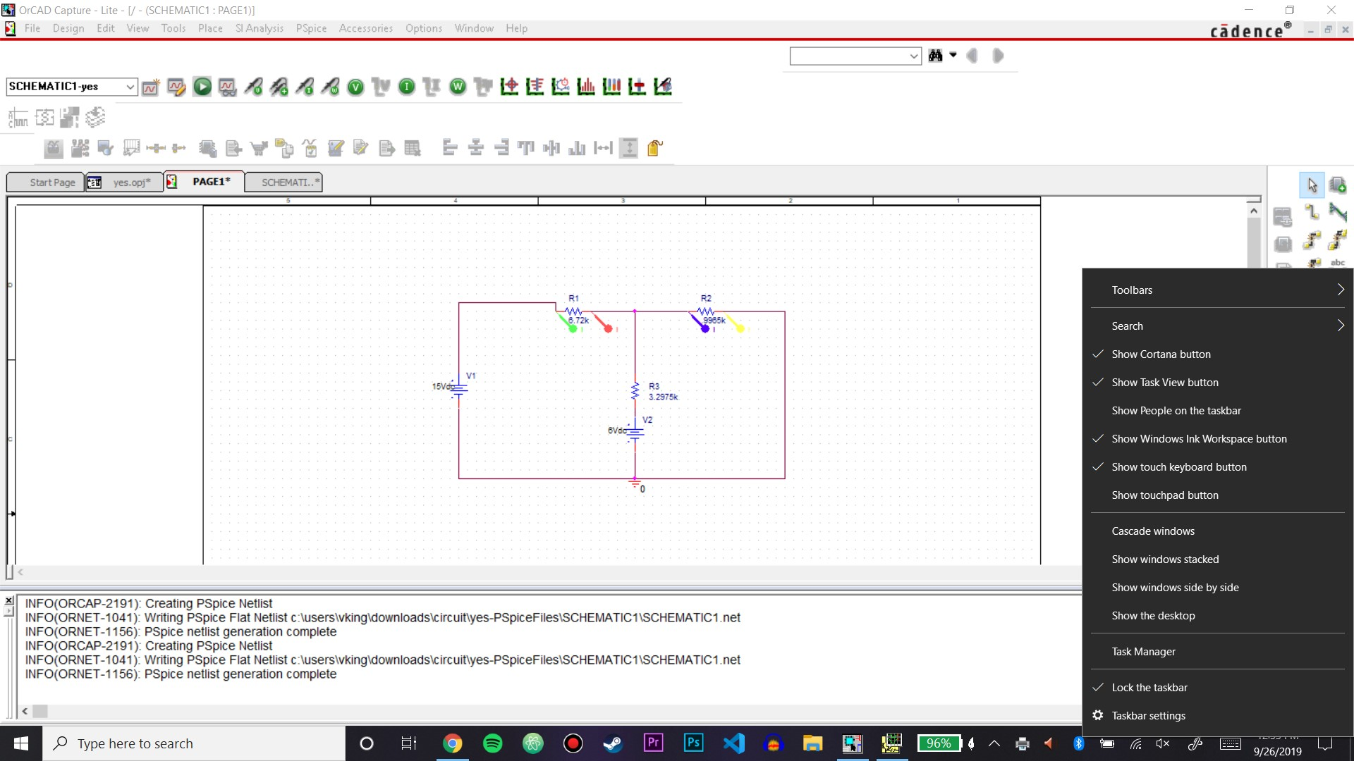

Output File

**** 09/26/19 12:34:03 ******* PSpice Lite (March 2016) ******* ID# 10813 ****

** Profile: "SCHEMATIC1-yes" [ c:\users\vking\downloads\circuit\yes-pspicefiles\schematic1\yes.sim ]

**** CIRCUIT DESCRIPTION

******************************************************************************

** Creating circuit file "yes.cir"

** WARNING: THIS AUTOMATICALLY GENERATED FILE MAY BE OVERWRITTEN BY SUBSEQUENT SIMULATIONS

*Libraries:

* Profile Libraries :

* Local Libraries :

* From [PSPICE NETLIST] section of C:\Users\Vking\AppData\Roaming\SPB_16.6\cdssetup\OrCAD_PSpice\17.2.0\PSpice.ini file:

.lib "nomd.lib"

*Analysis directives:

.TRAN 0 1000ns 0

.OPTIONS ACCT

.OPTIONS EXPAND

.OPTIONS LIBRARY

.OPTIONS LIST

.OPTIONS NODE

.OPTIONS OPTS

.OPTIONS ADVCONV

.PROBE64 V(*) I(*) W(*) D(*) NOISE(alias(*))

.INC "..\SCHEMATIC1.net"

**** INCLUDING SCHEMATIC1.net ****

* source YES

R_R2 N00576 0 .9965k TC=0,0

V_V1 N00532 0 15Vdc

R_R1 N00532 N00576 6.72k TC=0,0

R_R3 N00576 N00632 3.2975k TC=0,0

V_V2 N00632 0 6Vdc

**** RESUMING yes.cir ****

.END

**** 09/26/19 12:34:03 ******* PSpice Lite (March 2016) ******* ID# 10813 ****

** Profile: "SCHEMATIC1-yes" [ c:\users\vking\downloads\circuit\yes-pspicefiles\schematic1\yes.sim ]

**** ELEMENT NODE TABLE

******************************************************************************

0 R_R2 V_V1 V_V2

N00532 R_R1 V_V1

N00576 R_R1 R_R2 R_R3

N00632 R_R3 V_V2

**** 09/26/19 12:34:03 ******* PSpice Lite (March 2016) ******* ID# 10813 ****

** Profile: "SCHEMATIC1-yes" [ c:\users\vking\downloads\circuit\yes-pspicefiles\schematic1\yes.sim ]

**** CIRCUIT ELEMENT SUMMARY

******************************************************************************

**** RESISTORS

NAME NODES MODEL VALUE TC1 TC2 TCE

R_R2 N00576 0 9.97E+02

R_R1 N00532 N00576 6.72E+03

R_R3 N00576 N00632 3.30E+03

**** INDEPENDENT SOURCES

NAME NODES DC VALUE AC VALUE AC PHASE

V_V1 N00532 0 1.50E+01 0.00E+00 0.00E+00 degrees

V_V2 N00632 0 6.00E+00 0.00E+00 0.00E+00 degrees

**** 09/26/19 12:34:03 ******* PSpice Lite (March 2016) ******* ID# 10813 ****

** Profile: "SCHEMATIC1-yes" [ c:\users\vking\downloads\circuit\yes-pspicefiles\schematic1\yes.sim ]

**** OPTION SUMMARY

******************************************************************************

NODE LIST OPTS ACCT

DC ANALYSIS -

ITL1 = 150

ITL2 = 20

RELTOL = 1.0000E-03

ABSTOL = 1.0000E-12

VNTOL = 1.0000E-06

GMIN = 1.0000E-12

VLTEXPLIMIT = .5

DIODERS = 0

DIODECJO = 0

TRANSIENT ANALYSIS -

ITL4 = 10

TSTEPDIVFACTOR = 8

TRTOL = 7

CHGTOL = 10.0000E-15

DMFACTOR = 1

FSTDELFACTOR = 1

MISCELLANEOUS -

NUMDGT = 4

WIDTH = 80

DEFL = 100.0000E-06

DEFW = 100.0000E-06

DEFAD = 0

DEFAS = 0

TNOM = 27

RNDSEED = 0

DIGITAL -

DIGMNTYMX = 2

DIGIOLVL = 1

DIGINITSTATE = 2

DIGERRLIMIT = 0

DIGERRDEFAULT = 20

DIGFREQ = 10.0000E+09

DIGDRVF = 2

DIGDRVZ = 20.0000E+03

DIGOVRDRV = 2.5

DIGMNTYSCALE = .4

DIGTYMXSCALE = 1.6

**** 09/26/19 12:34:03 ******* PSpice Lite (March 2016) ******* ID# 10813 ****

** Profile: "SCHEMATIC1-yes" [ c:\users\vking\downloads\circuit\yes-pspicefiles\schematic1\yes.sim ]

**** INITIAL TRANSIENT SOLUTION TEMPERATURE = 27.000 DEG C

******************************************************************************

NODE VOLTAGE NODE VOLTAGE NODE VOLTAGE NODE VOLTAGE

(N00532) 15.0000 (N00576) 2.7836 (N00632) 6.0000

VOLTAGE SOURCE CURRENTS

NAME CURRENT

V_V1 -1.818E-03

V_V2 -9.754E-04

TOTAL POWER DISSIPATION 3.31E-02 WATTS

JOB CONCLUDED

**** 09/26/19 12:34:03 ******* PSpice Lite (March 2016) ******* ID# 10813 ****

** Profile: "SCHEMATIC1-yes" [ c:\users\vking\downloads\circuit\yes-pspicefiles\schematic1\yes.sim ]

**** JOB STATISTICS SUMMARY

******************************************************************************

Node counts:

Top level (NUNODS) = 4

External (NCNODS) = 4

Total (NUMNOD) = 4

Total device count (NUMEL) = 5

Resistors (R) = 3

Voltage Sources (V) = 2

Number of subcircuits (X) = 0

Matrix statistics:

Matrix size (NSTOP) = 6

Initial no. elements (NTTAR) = 11

No. elements w/ fillin (NTTBR) = 11

No. fillins (IFILL) = 0

No. overflows (NTTOV) = 2

No. LU operations (IOPS) = 0

Percent sparsity (PERSPA) = 69.444

Analysis statistics:

No. total time points (NUMTTP) = 107

No. rejected time points (NUMRTP) = 0

No. iterations (NUMNIT) = 321

Size of Probe file = 15280

Load Threads = 1

Runtime statistics: Seconds Iterations

Matrix load = 0.00

Matrix solution = 0.00 3

Readin = 0.00

General setup = 0.00

CMI setup = 0.00

Setup = 0.00

DC sweep = 0.00 0

Bias point = 0.00 5

AC and noise = 0.00 0

Total transient analysis = 0.00

Output = 0.00

Overhead = 0.00

Total job time (using Solver 1) = 0.00

The simulation yielded 2.7836 V for the voltage at node VA which is similar to the value we measured, about .15% difference. The simulation yielded 1.8179 mA for I1, about 1.26% difference from our measured value and 2.7933 mA for I2, about 3.11% difference. Overall, the results from our simulation were similar to the results we measured in the lab.